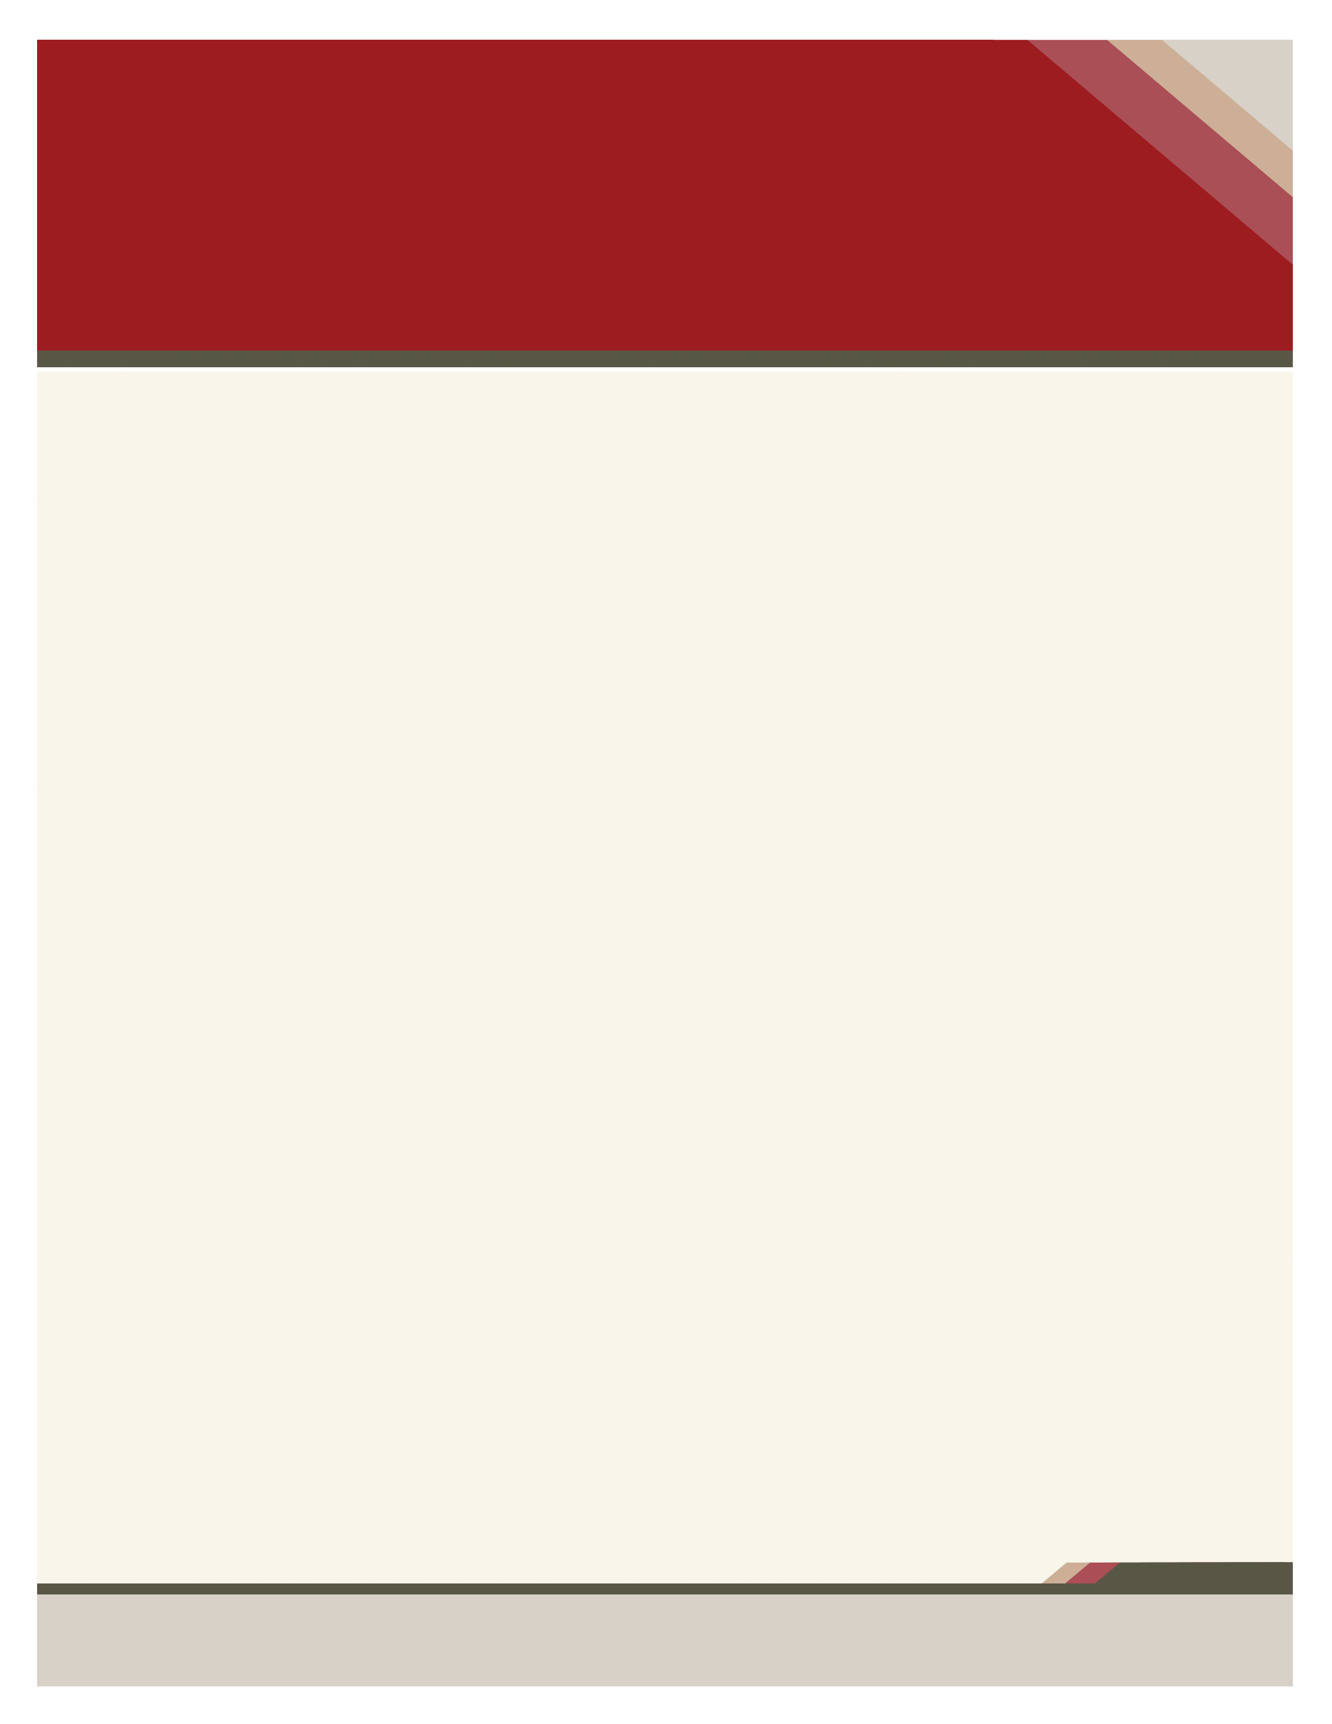
OHIO MATHEMATICAL ASSOCIATION OF AMERICA GREAT LAKES SOCIETY FOR INDUSTRIAL
AND APPLIED MATHEMATICS
SPRING MEETING
APRIL 4 - 5, 2014

Enter Contact Information Here | 1127 Lombard Blvd. San Francisco, CA 59802 | phone 555.555.5555 | fax 555.555.5555




FRIDAY, APRIL 4
Provide additional information or caption your photo here. Provide additional information or caption your photo here. Provide additional information or caption your photo here.

12:00 - 4:00 | Registration - FH - East Lobby
1:00 - 4:00 | Vendor & Book Exhibits - Atrium
1:30 - 1:45 | Welcome and Announcements  FH 2100
1:45 - 2:45 | Invited Address - FH 2100  Michael Dorff
2:45 - 3:10 | Break - Atrium
3:10 - 3:15 | Centennial Minute - FH 2100
3:15 - 4:15 | Invited Address - FH 2100  Steve Goldner and David A. Lamb
4:25 - 6:20 | Contributed Paper Sessions  FH 2200 - 2260
6:30 - 6:50 | Social Time - Libbey Hall
6:30 - 8:00 | Student Pizza Party - FH 2100
6:50 - 8:00 | Banquet - Libbey Hall
8:15 - 9:15 | After Dinner Panel Discussion  FH 2100

SATURDAY, APRIL 5
8:00 - 10:00 | Registration - FH - East Lobby
8:00 - 10:00 | Vendor & Book Exhibits - Atrium
8:00 - 8:50 | Coffee and Pastries - Atrium
8:50 - 9:00 | Welcome and Announcements  FH 2100
9:00 - 10:00 | Invited Address - FH 2100  Charles Groetsch
10:00 - 10:20 | Break
10:25 - 11:40 | Contributed Paper Sessions  FH 2200 - 2260
11:50 - 12:50 | Retiring President’s Address - Phil Blau - FH 2100
12:50 - 1:00 | Closing Remarks - FH 2100

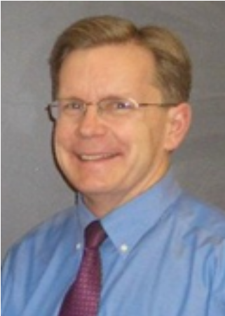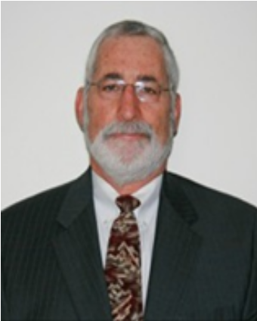
Michael Dorff Steve Goldner
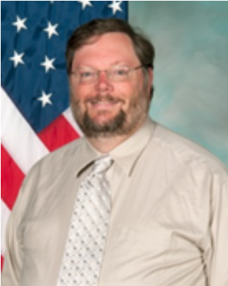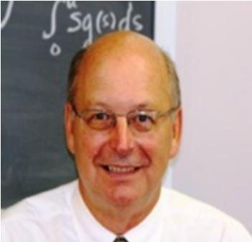
David A. Lamb Charles Groetsch
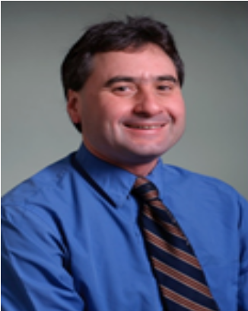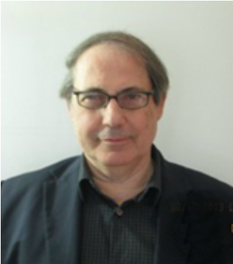
Phil Blau Emmanuel Tsimis

Information available at http://math.utoledo.edu/~janders/MAA-SIAMMeeting

