LESSON 14 AREA BETWEEN CURVES

Examples Find the area of the region bounded by the graphs of the given equations.

1. $y = 2 x^{ 2}$, $y = 6 x$

NOTE: The graph of the equation $y = 2 x^{ 2}$ is a parabola whose vertex is at the origin and opens upward. The graph of the equation $y = 6 x$ is a line with positive slope and whose y-intercept is the origin.

Using vertical rectangles:

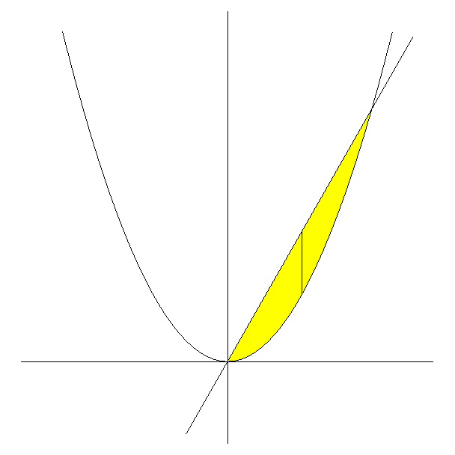
y
$y = 2 x^{ 2}$ $y = 6 x$

$( x , 6 x )$
Length = $6 x − 2 x^{ 2}$ ; Width = $\text{dx}$
$( x , 2 x^{ 2} )$

x x

The area of the i th rectangle is given by the product $( 6 x − 2 x^{ 2} ) \text{dx}$. In order to find the area of the enclosed region, we will need to sum the area of all these rectangles using integration.

In order to find the limits of integration, we will need to find the x-coordinate of the two points of intersection of the graphs. Since the y-coordinate of these points of intersection are the same and given by the equations $y = 2 x^{ 2}$ and $y = 6 x$, then we have that

$2 x^{ 2} = 6 x ⇒$ $2 x^{ 2} − 6 x = 0 ⇒$ $2 x ( x − 3 ) = 0 ⇒$ $x = 0$, $x = 3$

Thus, the first vertical rectangle in the region corresponds to when $x = 0$ and the last vertical rectangle in the region corresponds to when $x = 3$. Thus, we sum from $x = 0$ to $x = 3$. Thus, we obtain the following.

$\int{ ( 6x − 2 x^{ 2} ) \text{dx}}$ = $\frac{6 x^{ 2}}{2} − \frac{2 x^{ 3}}{3} ]_{ 0}^{ 3}$ = $3 x^{ 2} − \frac{2 x^{ 3}}{3} ]_{ 0}^{ 3}$ =

$\text{27} − \text{18} − ( 0 − 0 )$ = 9

Using horizontal rectangles:

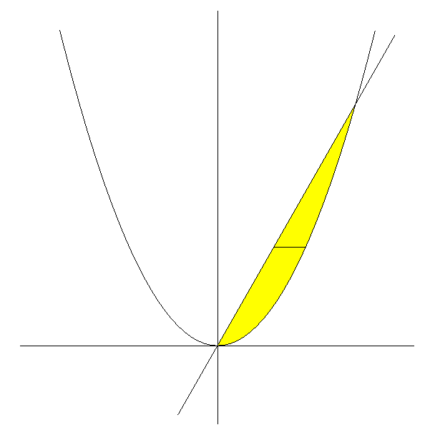
y
$y = 2 x^{ 2}$ $y = 6 x$

$\left( \frac{y}{6} , y \right)$
y $\left( \sqrt{ \frac{y}{2} } , y \right)$

x

Length = $\sqrt{ \frac{y}{2} } − \frac{y}{6}$ ; Width = $\text{dy}$

NOTE: $y = 2 x^{ 2} ⇒$ $x^{ 2} = \frac{y}{2} ⇒$ $x = ± \sqrt{ \frac{y}{2} }$

$y = 6 x ⇒$ $x = \frac{y}{6}$

The area of the i th rectangle is given by the product $\left( \sqrt{ \frac{y}{2} } − \frac{y}{6} \right) \text{dy}$. In order to find the area of the enclosed region, we will need to sum the area of all these rectangles using integration.

In order to find the limits of integration, we will need to find the y-coordinate of the two points of intersection of the graphs.

In the work above, we found that the x-coordinate of these points of intersection were $x = 0$ and $x = 3$. Then we can use the equation $y = 6 x$ (or the equation $y = 2 x^{ 2}$) to find the y-coordinate of the points of intersection. When $x = 0$, $y = 0$. When $x = 3$, $y = 6 ( 3 )$ = 18.

Thus, the first horizontal rectangle in the region corresponds to when $y = 0$ and the last horizontal rectangle in the region corresponds to when $y = \text{18}$. Thus, we sum from $y = 0$ to $y = \text{18}$. Thus, we obtain the following.

$\int{ \left( \sqrt{ \frac{y}{2} } − \frac{y}{6} \right) \text{dy}}$ = $\int{ \left( \frac{\sqrt{ y }}{\sqrt{ 2 }} − \frac{y}{6} \right) \text{dy}}$ = $\int{ \left( \frac{1}{\sqrt{ 2 }} y^{ 1/2} − \frac{1}{6} y \right) \text{dy}}$ =

$\frac{1}{\sqrt{ 2 }} ⋅\frac{2}{3} y^{ 3/2} − \frac{1}{6} ⋅ \frac{y^{ 2}}{2} ]_{ 0}^{ \text{18}}$ = $\frac{2 \sqrt{ 2 }}{6} y^{ 3/2} − \frac{y^{ 2}}{\text{12}} ]_{ 0}^{ \text{18}}$ = $\frac{1}{\text{12}} y ( 4 \sqrt{ 2 } y^{ 1/2} − y ) ]_{ 0}^{ \text{18}}$ =

$\frac{\text{18}}{\text{12}} ( 4 \sqrt{ 2 } \sqrt{ \text{18} } − \text{18} )$ = $\frac{3}{2} ( 4 \sqrt{ \text{36} } − \text{18} )$ = $\frac{3}{2} [ 4 ( 6 ) − \text{18} ]$ = $\frac{3}{2} [ \text{24} − \text{18} ]$ =

$\frac{3}{2} ( 6 )$ = 9

Answer: 9

2. $x = y^{ 2} − 8$, $3 x = − y^{ 2}$

NOTE: Since $x = y^{ 2} − 8 ⇒$ $x + 8 = y^{ 2}$, then the graph of the equation $x = y^{ 2} − 8$ is the graph of the equation $x = y^{ 2}$ shifted eight units to the left. The graph of the equation $x = y^{ 2}$ is a parabola whose vertex is at the origin and opens to the right. Since $3 x = − y^{ 2} ⇒$ $x = − \frac{1}{3} y^{ 2}$, then the graph of the equation $3 x = − y^{ 2} ⇒$ is a parabola whose vertex is at the origin and opens to the left.

Using horizontal rectangles:
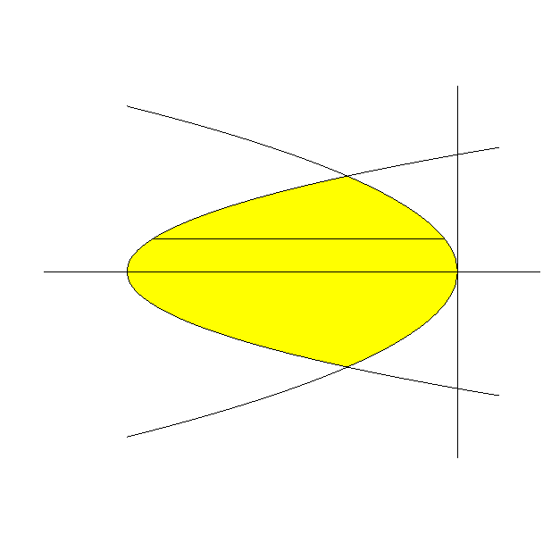

y $x = y^{ 2} − 8$

$\left( − \frac{1}{3} y^{ 2} , y \right)$
$( y^{ 2} − 8 , y )$ y
x
$− 8$

$$x = − \frac{1}{3} y^{ 2}$$

Length = $− \frac{1}{3} y^{ 2} − ( y^{ 2} − 8 )$ = $8 − \frac{4}{3} y^{ 2}$

Width = $\text{dy}$

The area of the i th rectangle is given by the product $\left( 8 − \frac{4}{3} y^{ 2} \right) \text{dy}$. In order to find the area of the enclosed region, we will need to sum the area of all these rectangles using integration.

In order to find the limits of integration, we will need to find the y-coordinate of the two points of intersection of the graphs. Since the x-coordinate of these points of intersection are the same and given by the equations $x = y^{ 2} − 8$ and $x = − \frac{1}{3} y^{ 2}$, then we have that

$y^{ 2} − 8 = − \frac{1}{3} y^{ 2} ⇒$ $3 y^{ 2} − \text{24} = − y^{ 2} ⇒$ $4 y^{ 2} = \text{24} ⇒$ $y^{ 2} = 6 ⇒$ $y = ± \sqrt{ 6 }$

Thus, the first horizontal rectangle in the region corresponds to when $y = − \sqrt{ 6 }$ and the last horizontal rectangle in the region corresponds to when $y = \sqrt{ 6 }$. Thus, we sum from $y = − \sqrt{ 6 }$ to $y = \sqrt{ 6 }$. Thus, we obtain the following.

$$\int{ \left( 8 − \frac{4}{3} y^{ 2} \right) \text{dy}}$$

Since the integrand of $f( y ) = 8 − \frac{4}{3} y^{ 2}$ is an even function, then we may write

$\int{ \left( 8 − \frac{4}{3} y^{ 2} \right) \text{dy}}$ = $2 \int{ \left( 8 − \frac{4}{3} y^{ 2} \right) \text{dy}}$ = $8 \int{ \left( 2 − \frac{1}{3} y^{ 2} \right) \text{dy}}$ =

$8 {\left[ 2 y − \frac{1}{3} ⋅ \frac{y^{ 3}}{3} \right]}_{ 0}^{ \sqrt{ 6 }}$ = $8 {\left[ 2 y − \frac{y^{ 3}}{9} \right]}_{ 0}^{ \sqrt{ 6 }}$ = $\frac{8}{9} y ( \text{18} − y^{ 2} ) ]_{ 0}^{ \sqrt{ 6 }}$ =

$\frac{8}{9} \sqrt{ 6 } ( \text{18} − 6 )$ = $\frac{8}{9} \sqrt{ 6 } ( \text{12} )$ = $\frac{8}{3} \sqrt{ 6 } ( 4 )$ = $\frac{\text{32} \sqrt{ 6 }}{3}$

Using vertical rectangles:

$x = y^{ 2} − 8 ⇒$ $y^{ 2} = x + 8 ⇒$ $\left| y \right| = \sqrt{ x + 8 } ⇒$ $y = ± \sqrt{ x + 8 }$

NOTE: The equation $y = \sqrt{ x + 8 }$ is the top half of the parabola $x = y^{ 2} − 8$ and the equation $y = − \sqrt{ x + 8 }$ is the bottom half of the parabola.

$x = − \frac{1}{3} y^{ 2} ⇒$ $3 x = − y^{ 2} ⇒$ $y^{ 2} = − 3 x ⇒$ $\left| y \right| = \sqrt{ − 3 x } ⇒$ $y = ± \sqrt{ − 3 x }$

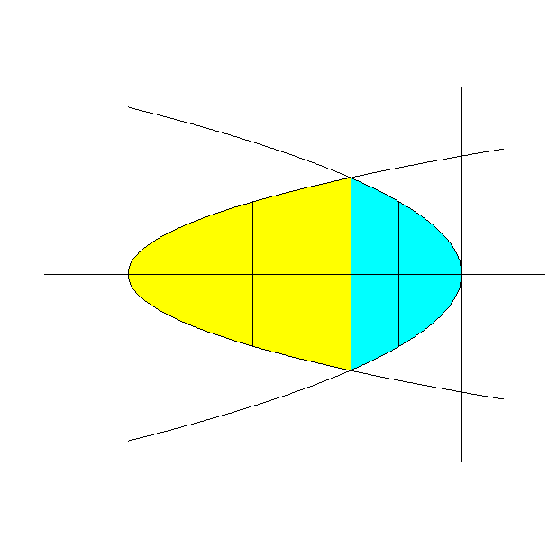
NOTE: The equation $y = \sqrt{ − 3 x }$ is the top half of the parabola $x = − \frac{1}{3} y^{ 2}$ and the equation $y = − \sqrt{ − 3 x }$ is the bottom half of the parabola.

$y = \sqrt{ − 3 x }$ y $y = \sqrt{ x + 8 }$

$( x , \sqrt{ x + 8 } )$ $( x , \sqrt{ − 3 x } )$

Length = $2 \sqrt{ x + 8 }$ Length = $2 \sqrt{ − 3 x }$
$− 8$ x $− 2$ x x

$( x , − \sqrt{ x + 8 } )$ $( x , − \sqrt{ − 3 x } )$

$y = − \sqrt{ x + 8 }$
$$y = − \sqrt{ − 3 x }$$
Width = $\text{dx}$

NOTE: We found that the y-coordinates of the two points of intersection of the equations $x = y^{ 2} − 8$ and $x = − \frac{1}{3} y^{ 2}$ were $y = ± \sqrt{ 6 }$. Thus, the x-coordinate of these points can be obtained using the equation $x = y^{ 2} − 8$ or the equation $x = − \frac{1}{3} y^{ 2}$. Using $x = y^{ 2} − 8$, we have that $x = y^{ 2} − 8$ = $( ± \sqrt{ 6 } )^{ 2} − 8$ = $6 − 8 = − 2$.

To find the area of the yellow shaded region:

The area of the i th rectangle is given by the product $2 \sqrt{ x + 8 } \text{dx}$. In order to find the area of the enclosed region, we will need to sum the area of all these rectangles using integration.

The first vertical rectangle in the yellow region corresponds to when $x = − 8$ and the last vertical rectangle in the yellow region corresponds to when $x = − 2$. Thus, we sum from $x = − 8$ to $x = − 2$. Thus, we obtain the following.

$$\int{ 2 \sqrt{ x + 8 } \text{dx}}$$

Let $u = x + 8$
Then $d u = \text{dx}$

$\int{ 2 \sqrt{ x + 8 } \text{dx}}$ = $2 \int{ \sqrt{ u } \text{du}}$ = $2 \int{ u^{ 1/2} \text{du}}$ = $2 ⋅ \frac{2}{3} u^{ 3/2} ]_{ 0}^{ 6}$ =

$\frac{4}{3} {\left[ u^{ 3/2} \right]}_{ 0}^{ 6}$ = $\frac{4}{3} ( 6^{ 3/2} − 0 )$ = $\frac{4}{3} ( 6 \sqrt{ 6 } )$ = $8 \sqrt{ 6 }$

Thus, the area of the yellow region, which is given by $\int{ 2 \sqrt{ x + 8 } \text{dx}}$, is $8 \sqrt{ 6 }$.

To find the area of the aqua shaded region:

The area of the i th rectangle is given by the product $2 \sqrt{ − 3 x } \text{dx}$. In order to find the area of the enclosed region, we will need to sum the area of all these rectangles using integration.

The first vertical rectangle in the yellow region corresponds to when $x = − 2$ and the last vertical rectangle in the yellow region corresponds to when $x = 0$. Thus, we sum from $x = − 2$ to $x = 0$. Thus, we obtain the following.

$$\int{ 2 \sqrt{ − 3 x } \text{dx}}$$

$\int{ 2 \sqrt{ − 3 x } \text{dx}}$ = $\int{ 2 \sqrt{ 3 } \sqrt{ − x } \text{dx}}$ = $2 \sqrt{ 3 } \int{ \sqrt{ − x } \text{dx}}$

Let $u = − x$
Then $d u = − \text{dx}$

$2 \sqrt{ 3 } \int{ \sqrt{ − x } \text{dx}}$ = $− 2 \sqrt{ 3 } \int{ \sqrt{ − x } ( − 1 ) \text{dx}}$ = $− 2 \sqrt{ 3 } \int{ \sqrt{ u } \text{du}}$ = $2 \sqrt{ 3 } \int{ \sqrt{ u } \text{du}}$ = $2 \sqrt{ 3 } \int{ u^{ 1/2} \text{du}}$ = $2 \sqrt{ 3 } ⋅ \frac{2}{3} u^{ 3/2} ]_{ 0}^{ 2}$ =

$\frac{4 \sqrt{ 3 }}{3} {\left[ u^{ 3/2} \right]}_{ 0}^{ 2}$ = $\frac{4 \sqrt{ 3 }}{3} ( 2^{ 3/2} − 0 )$ = $\frac{4 \sqrt{ 3 }}{3} ( 2 \sqrt{ 2 } )$ = $\frac{8 \sqrt{ 6 }}{3}$

Thus, the area of the aqua region, which is given by $\int{ 2 \sqrt{ − 3 x } \text{dx}}$, is $\frac{8 \sqrt{ 6 }}{3}$.

Thus, the area of the enclosed region is given by

$\int{ 2 \sqrt{ x + 8 } \text{dx}}$ + $\int{ 2 \sqrt{ − 3 x } \text{dx}}$ = $8 \sqrt{ 6 }$ + $\frac{8 \sqrt{ 6 }}{3}$ = $\frac{\text{24} \sqrt{ 6 }}{3}$ + $\frac{8 \sqrt{ 6 }}{3}$ =

$$\frac{\text{32} \sqrt{ 6 }}{3}$$

Answer: $\frac{\text{32} \sqrt{ 6 }}{3}$

3. $y = \frac{5}{x^{ 2}}$, $y = − 4 x^{ 2} − 3$, $x = 1$, $x = 4$

NOTE: The graph of the equation $y = \frac{5}{x^{ 2}}$ has the y-axis as a vertical asymptote and the x-axis as a horizontal asymptote. Since $\frac{5}{x^{ 2}}$ is positive for all $x ≠ 0$, then the graph of the equation $y = \frac{5}{x^{ 2}}$ lies above the x-axis. Since $y = − 4 x^{ 2} − 3 ⇒$ $y + 3 = − 4 x^{ 2}$, then the graph of the equation $y = − 4 x^{ 2} − 3$ is the graph of the equation $y = − 4 x^{ 2}$ shifted three units downward. The graph of the equation $y = − 4 x^{ 2}$ is a parabola whose vertex is at the origin and opens downward. The graph of the equation $x = 1$ is a vertical line which crosses the x-axis at 1. The graph of the equation $x = 4$ is a vertical line which crosses the x-axis at 4.

y
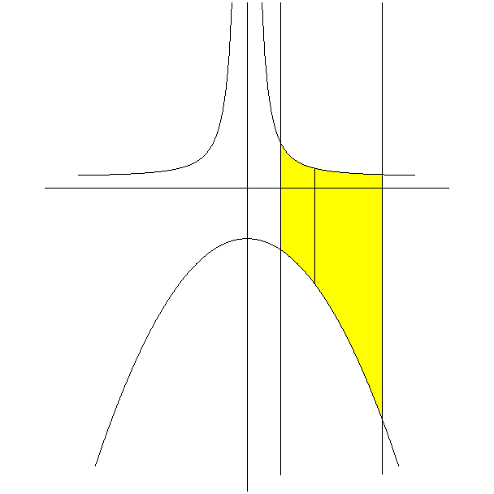

$y = \frac{5}{x^{ 2}}$ $\left( x , \frac{5}{x^{ 2}} \right)$

1 x 4 x

$( x , − 4 x^{ 2} − 3 )$ Length = $\frac{5}{x^{ 2}} − ( − 4 x^{ 2} − 3 )$ = $\frac{5}{x^{ 2}} + 4 x^{ 2} + 3$

Width = $\text{dx}$
$y = − 4 x^{ 2} − 3$

$x = 1$ $x = 4$

The area of the i th rectangle is given by the product $\left( \frac{5}{x^{ 2}} + 4 x^{ 2} + 3 \right) \text{dx}$. In order to find the area of the enclosed region, we will need to sum the area of all these rectangles using integration.

The first vertical rectangle in the region corresponds to when $x = 1$ and the last vertical rectangle in the region corresponds to when $x = 4$. Thus, we sum from $x = 1$ to $x = 4$. Thus, we obtain the following.

$\int{ \left( \frac{5}{x^{ 2}} + 4 x^{ 2} + 3 \right) \text{dx}}$ = $\int{ ( 5 x^{ − 2} + 4 x^{ 2} + 3 ) \text{dx}}$ =

$\frac{5 x^{ − 1}}{− 1} + \frac{4 x^{ 3}}{3} + 3 x ]_{ 1}^{ 4}$ = $− \frac{5}{x} + \frac{4 x^{ 3}}{3} + 3 x ]_{ 1}^{ 4}$ =

$− \frac{5}{4} + \frac{\text{256}}{3} + \text{12} − \left( − 5 + \frac{4}{3} + 3 \right)$ = $− \frac{5}{4} + \frac{\text{256}}{3} + \text{12} + 2 − \frac{4}{3}$ =

$− \frac{5}{4} + \frac{\text{252}}{3} + \text{14}$ = $− \frac{5}{4} + \text{84} + \text{14}$ = $− \frac{5}{4} + \text{98}$ = $− \frac{5}{4} + \frac{\text{392}}{4}$ = $\frac{\text{387}}{4}$

Answer: $\frac{\text{387}}{4}$

4. $x = \frac{1}{2} y^{ 2} + 4 y$, $x = \text{16} − 3 y$

NOTE: The graph of the equation $x = \frac{1}{2} y^{ 2} + 4 y$ is a parabola that opens to the right from its vertex. We need to find the coordinates of this vertex. Since $x = \frac{1}{2} y^{ 2} + 4 y ⇒$ $x = \frac{1}{2} y ( y + 8 )$, then the y-coordinates of the y-intercepts of the graph of the parabola are $y = 0$ and $y = − 8$. Thus, the axis of symmetry for the parabola is the horizontal line $y = − 4$. Since the vertex of the parabola lies on this axis of symmetry, then the y-coordinate of the vertex is $y = − 4$. Since $x = \frac{1}{2} y ( y + 8 )$, then we can find the x-coordinate for the vertex by $x = \frac{1}{2} ( − 4 ) ( − 4 + 8 )$ = $\frac{1}{2} ( − 4 ) ( 4 )$ = $− 8$. Thus, the vertex of the parabola is $( − 8 , − 4 )$. The graph of the equation $x = \text{16} − 3 y$ is a line.

Using horizontal rectangles:

$x = \text{16} − 3 y$ y
$x = \frac{1}{2} y^{ 2} + 4 y$

x

$\left( \frac{1}{2} y^{ 2} + 4 y , y \right)$ y $( \text{16} − 3 y , y )$

Length = $\text{16} − 3 y − \left( \frac{1}{2} y^{ 2} + 4 y \right)$ = $\text{16} − 7 y − \frac{1}{2} y^{ 2}$
Width = $\text{dy}$

The area of the i th rectangle is given by the product $\left( \text{16} − 7 y − \frac{1}{2} y^{ 2} \right) \text{dy}$. In order to find the area of the enclosed region, we will need to sum the area of all these rectangles using integration.

In order to find the limits of integration, we will need to find the y-coordinate of the two points of intersection of the graphs. Since the x-coordinate of these points of intersection are the same and given by the equations $x = \frac{1}{2} y^{ 2} + 4 y$ and $x = \text{16} − 3 y$, then we have that

$\frac{1}{2} y^{ 2} + 4 y = \text{16} − 3 y ⇒$ $y^{ 2} + 8 y = \text{32} − 6 y ⇒$ $y^{ 2} + \text{14} y − \text{32} = 0 ⇒$

$( y + \text{16} ) ( y − 2 ) = 0 ⇒$ $y = − \text{16}$ , $y = 2$

Thus, the first horizontal rectangle in the region corresponds to when $y = − \text{16}$ and the last horizontal rectangle in the region corresponds to when $y = 2$. Thus, we sum from $y = − \text{16}$ to $y = 2$. Thus, we obtain the following.

$\int{ \left( \text{16} − 7 y − \frac{1}{2} y^{ 2} \right) \text{dy}}$ = $\text{16} y − \frac{7y^{ 2}}{2} − \frac{1}{2} ⋅ \frac{y^{ 3}}{3} ]_{ − \text{16}}^{ 2}$ =

$\text{16} y − \frac{7y^{ 2}}{2} − \frac{y^{ 3}}{6} ]_{ − \text{16}}^{ 2}$ = $\frac{1}{6} {\left[ y ( \text{96} − \text{21} y − y^{ 2} ) \right]}_{ − \text{16}}^{ 2}$ =

$\frac{1}{6} \left\{ 2 ( \text{96} − \text{42} − 4 ) + \text{16} [ \text{96} + \text{21} ( \text{16} ) − ( \text{16} ) ( \text{16} ) ] \right\}$ =

$\frac{1}{6} [ 2 ( \text{50} ) + \text{16} ( \text{16} ) ( 6 + \text{21} − \text{16} ) ]$ = $\frac{1}{6} [ \text{100} + \text{16} ( \text{16} ) ( \text{11} ) ]$ =

$\frac{1}{6} ( 4 ) [ \text{25} + 4 ( \text{16} ) ( \text{11} ) ]$ = $\frac{2}{3} [ \text{25} + \text{64} ( \text{11} ) ]$ = $\frac{2}{3} ( \text{25} + \text{704} )$ = $\frac{2}{3} ( \text{729} )$ =

$\frac{2}{1} ( \text{243} )$ = 486

Using vertical rectangles:

$x = \frac{1}{2} y^{ 2} + 4 y ⇒$ $2 x = y^{ 2} + 8 y ⇒$ $2 x + \text{16} = y^{ 2} + 8 y + \text{16} ⇒$

$2 x + \text{16} = ( y + 4 )^{ 2} ⇒$ $\left| y + 4 \right| = \sqrt{ 2 x + \text{16} } ⇒$ $y + 4 = ± \sqrt{ 2 x + \text{16} } ⇒$

$$y = − 4 ± \sqrt{ 2 x + \text{16} }$$

NOTE: The equation $y = − 4 + \sqrt{ 2 x + \text{16} }$ is the top half of the parabola $x = \frac{1}{2} y^{ 2} + 4 y$ and the equation $y = − 4 − \sqrt{ 2 x + \text{16} }$ is the bottom half of the parabola.

$x = \text{16} − 3 y ⇒$ $3 y = \text{16} − x ⇒$ $y = \frac{1}{3} ( \text{16} − x )$
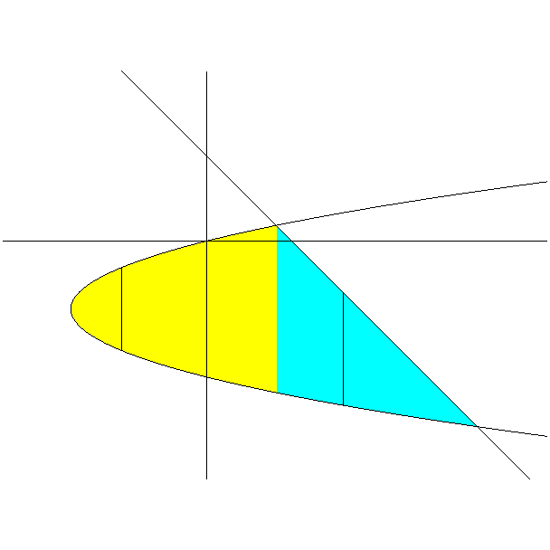
$y = \frac{1}{3} ( \text{16} − x )$ y
$y = − 4 + \sqrt{ 2 x + \text{16} }$

$( \text{10} , 2 )$
x x x
$( x , − 4 + \sqrt{ 2 x + \text{16} } )$ $\left( x , \frac{1}{3} ( \text{16} − x ) \right)$
$( − 8 , − 4 )$
$( x , − 4 − \sqrt{ 2 x + \text{16} } )$
$( x , − 4 − \sqrt{ 2 x + \text{16} } )$ $( \text{64} , − \text{16} )$

$y = − 4 − \sqrt{ 2 x + \text{16} }$

The length of the vertical rectangle in the yellow shaded region is given by $− 4 + \sqrt{ 2 x + \text{16} } − ( − 4 − \sqrt{ 2 x + \text{16} } )$ = $− 4 + \sqrt{ 2 x + \text{16} } + 4 + \sqrt{ 2 x + \text{16} }$ =
$2 \sqrt{ 2 x + \text{16} }$.

The length of the vertical rectangle in the aqua shaded region is given by $\frac{1}{3} ( \text{16} − x ) − ( − 4 − \sqrt{ 2 x + \text{16} } )$ = $\frac{1}{3} ( \text{16} − x ) + 4 + \sqrt{ 2 x + \text{16} }$.

The width of each vertical rectangle is $\text{dx}$.

NOTE: We found that the y-coordinates of the two points of intersection of the equations $x = \frac{1}{2} y^{ 2} + 4 y$ and $x = \text{16} − 3 y$ were $y = − \text{16}$ and $y = 2$. Thus, the x-coordinate of these points can be obtained using the equation $x = \frac{1}{2} y^{ 2} + 4 y$ or the equation $x = \text{16} − 3 y$. Using $x = \text{16} − 3 y$, we have that $x = \text{16} − 3 y$ = $\text{16} + \text{48} = \text{64}$ when $y = − \text{16}$ and $x = \text{16} − 3 y$ = $\text{16} − 6 = \text{10}$ when $y = 2$.

To find the area of the yellow shaded region:

The area of the i th rectangle is given by the product $2 \sqrt{ 2 x + \text{16} } \text{dx}$. In order to find the area of the enclosed region, we will need to sum the area of all these rectangles using integration.

The first vertical rectangle in the yellow region corresponds to when $x = − 8$ and the last vertical rectangle in the yellow region corresponds to when $x = \text{10}$. Thus, we sum from $x = − 8$ to $x = \text{10}$. Thus, we obtain the following.

$\int{ 2 \sqrt{ 2 x + \text{16} } \text{dx}}$ = $\int{ 2 \sqrt{2} \sqrt{ x + 8 } \text{dx}}$

Let $u = x + 8$
Then $d u = \text{dx}$

$\int{ 2 \sqrt{2} \sqrt{ x + 8 } \text{dx}}$ = $2 \sqrt{2} \int{ \sqrt{ u } \text{du}}$ = $2 \sqrt{2} \int{ u^{ 1/2} \text{du}}$ =

$2 \sqrt{2} ⋅ \frac{2}{3} u^{ 3/2} ]_{ 0}^{ \text{18}}$ = $\frac{4 \sqrt{2}}{3} {\left[ u^{ 3/2} \right]}_{ 0}^{ \text{18}}$ = $\frac{4 \sqrt{2}}{3} ( {\text{18}}^{ 3/2} − 0 )$ = $\frac{4 \sqrt{2}}{3} ( \text{18} \sqrt{ \text{18} } )$ =

$$\frac{4 \sqrt{2}}{1} ( 6 \sqrt{ \text{18} } ) = \text{24} \sqrt{ \text{36} } = \text{24} ( 6 ) = \text{144}$$

Thus, the area of the yellow region, which is given by $\int{ 2 \sqrt{ 2 x + \text{16} } \text{dx}}$, is 144.

To find the area of the aqua shaded region:

The area of the i th rectangle is given by the product $\left[ \frac{1}{3} ( \text{16} − x ) + 4 + \sqrt{ 2 x + \text{16} } \right] \text{dx}$. In order to find the area of the enclosed region, we will need to sum the area of all these rectangles using integration.

The first vertical rectangle in the yellow region corresponds to when $x = \text{10}$ and the last vertical rectangle in the yellow region corresponds to when $x = \text{64}$. Thus, we sum from $x = \text{10}$ to $x = \text{64}$. Thus, we obtain the following.

$\int{ \left[ \frac{1}{3} ( \text{16} − x ) + 4 + \sqrt{ 2 x + \text{16} } \right] \text{dx}}$ =

$\int{ \left[ \frac{1}{3} ( \text{16} − x ) + 4 + \sqrt{ 2 } \sqrt{ x + 8 } \right] \text{dx}}$ =

$− \frac{1}{3} ⋅ \frac{( \text{16} − x )^{ 2}}{2} + 4 x + \sqrt{ 2 } ⋅ \frac{2}{3} ( x + 8 )^{ 3/2} ]_{ \text{10}}^{ \text{64}}$ =

$− \frac{1}{6} ( \text{16} − x )^{ 2} + 4 x + \frac{2 \sqrt{ 2 }}{3} ( x + 8 )^{ 3/2} ]_{ \text{10}}^{ \text{64}}$ =

$− \frac{1}{6} ( − \text{48} )^{ 2} + \text{256} + \frac{2 \sqrt{ 2 }}{3} ( \text{72} )^{ 3/2} − \left[ − \frac{1}{6} ( 6 )^{ 2} + \text{40} + \frac{2 \sqrt{ 2 }}{3} ( \text{18} )^{ 3/2} \right]$ =

$− \frac{1}{6} ( \text{48} ) ( \text{48} ) + \text{256} + \frac{2 \sqrt{ 2 }}{3} ⋅ \text{72} \sqrt{ \text{72} } + 6 − \text{40} − \frac{2 \sqrt{ 2 }}{3} ⋅ \text{18} \sqrt{ \text{18} }$ =

$− 8 ( \text{48} ) + \text{222} + 2 \sqrt{ 2 } ⋅ \text{24} ⋅ 6 \sqrt{ 2 } − 2 \sqrt{ 2 } ⋅ 6 ⋅ 3 \sqrt{ 2 }$ =

$− \text{384} + \text{222} + \text{48} ⋅ 6 ⋅ 2 − \text{36} ⋅ 2$ = $− \text{162} + \text{12} ⋅ 3 ⋅ 2 ( 4 ⋅ 2 ⋅ 1 − 1 )$ =

$− \text{162} + \text{72} ( 7 )$ = $− \text{162} + \text{504} = \text{342}$

Thus, the area of the aqua region, which is given by $\int{ \left[ \frac{1}{3} ( \text{16} − x ) + 4 + \sqrt{ 2 x + \text{16} } \right] \text{dx}}$, is 342.

Thus, the area of the enclosed region is given by

$\int{ 2 \sqrt{ 2 x + \text{16} } \text{dx}}$ + $\int{ \left[ \frac{1}{3} ( \text{16} − x ) + 4 + \sqrt{ 2 x + \text{16} } \right] \text{dx}}$ = 144 + 342 =
486

Answer: 486

5. $y = \text{cos} 2x$, $y = e^{ x/4}$, $x = 0$, $x = \frac{π}{2}$

NOTE: The graph of the equation $y = \text{cos} 2x$ has an amplitude of 1 and a period of $π$. The graph of the equation $x = 0$ is the y-axis. The graph of the equation $x = \frac{π}{2}$ is a vertical line which crosses the x-axis at $\frac{π}{2}$.

y
$y = e^{ x/4}$

$( x , e^{ x/4} )$

Length = $e^{ x/4} − \text{cos} 2 x$ ; Width = $\text{dx}$

x
$( x , \text{cos} 2x )$
$y = \text{cos} 2x$

$x = \frac{π}{2}$

The area of the i th rectangle is given by the product $( e^{ x/4} − \text{cos} 2 x ) \text{dx}$. In order to find the area of the enclosed region, we will need to sum the area of all these rectangles using integration.

The first vertical rectangle in the region corresponds to when $x = 0$ and the last vertical rectangle in the region corresponds to when $x = \frac{π}{2}$. Thus, we sum from $x = 0$ to $x = \frac{π}{2}$. Thus, we obtain the following.

$\int{ ( e^{ x/4} − \text{cos} 2 x ) \text{dx}}$ = $4 e^{ x/4} − \frac{1}{2} \text{sin} 2x ]_{ 0}^{ π/2}$ =

$4 e^{ π/8} − \frac{1}{2} \text{sin} π − \left( 4 − \frac{1}{2} \text{sin} 0 \right)$ = $4 e^{ π/8} − 4$ = $4 ( e^{ π/8} − 1 )$

NOTE: $\text{sin} π = 0 = \text{sin} 0$

Answer: $4 ( e^{ π/8} − 1 )$

6. $y = \sqrt{ − x }$, $y = 4$, $x = 0$

NOTE: Since $y = \sqrt{ − x } ⇒$ $y^{ 2} = − x ⇒$ $x = − y^{ 2}$, then the graph of the equation $y = \sqrt{ − x }$ is the top half of the parabola whose vertex is at the origin and opens to the left. The graph of the equation $y = 4$ is a horizontal line which crosses the y-axis at 4. The graph of the equation $x = 0$ is the y-axis.

Using vertical rectangles:

$y = \sqrt{ − x }$ y
$( x , 4 )$ 4
Length = $4 − \sqrt{ − x }$ ; Width = $\text{dx}$
$( x , \sqrt{ − x } )$

$− \text{16}$ x x
The area of the i th rectangle is given by the product $( 4 − \sqrt{ − x } ) \text{dx}$. In order to find the area of the enclosed region, we will need to sum the area of all these rectangles using integration.

Since the last vertical rectangle in the region corresponds to when $x = 0$, the upper limit of integration is $x = 0$. In order to find the lower limit of integration, we will need to find the x-coordinate of the point of intersection of the graphs of $y = \sqrt{ − x }$ and $y = 4$. Thus, we have that

$\sqrt{ − x } = 4 ⇒$ $− x = \text{16} ⇒$ $x = − \text{16}$

Thus, the lower limit of integration is $x = − \text{16}$. Thus, the first vertical rectangle in the region corresponds to when $x = − \text{16}$. Thus, we sum from $x = − \text{16}$ to $x = 0$. Thus, we obtain the following.

$$\int{ ( 4 − \sqrt{ − x } ) \text{dx}}$$

Let $u = − x$
Then $u = − \text{dx}$

$\int{ ( 4 − \sqrt{ − x } ) \text{dx}}$ = $− \int{ ( 4 − \sqrt{ − x } ) ( − 1 ) \text{dx}}$ = $− \int{ ( 4 − \sqrt{ u } ) \text{du}}$ =

$\int{ ( 4 − \sqrt{ u } ) \text{du}}$ = $\int{ ( 4 − u^{ 1/2} ) \text{du}}$ = $\int{ ( 4 − u^{ 1/2} ) \text{du}}$ =

$4 u − \frac{2}{3} u^{ 3/2} ]_{ 0}^{ \text{16}}$ = $\text{64} − \frac{2}{3} ⋅ {\text{16}}^{ 3/2} − ( 0 − 0 )$ = $\text{64} − \frac{2}{3} ( \text{64} )$ =

$\text{64} \left( 1 − \frac{2}{3} \right)$ = $\text{64} \left( \frac{1}{3} \right)$ = $\frac{\text{64}}{3}$

Using horizontal rectangles:

$y = \sqrt{ − x }$ y
4

$( − y^{ 2} , y )$ $( 0 , y )$

$− \text{16}$ x

Length = $0 − ( − y^{ 2} )$ = $y^{ 2}$ ; Width = $\text{dy}$

NOTE: $y = \sqrt{ − x } ⇒$ $y^{ 2} = − x ⇒$ $x = − y^{ 2}$

The area of the i th rectangle is given by the product $y^{ 2} \text{dy}$. In order to find the area of the enclosed region, we will need to sum the area of all these rectangles using integration.

Thus, the first horizontal rectangle in the region corresponds to when $y = 0$ and the last horizontal rectangle in the region corresponds to when $y = 4$. Thus, we sum from $y = 0$ to $y = 4$. Thus, we obtain the following.

$\int{ y^{ 2} \text{dy}}$ = $\frac{y^{ 3}}{3} ]_{ 0}^{ 4}$ = $\frac{1}{3} {\left[ y^{ 3} \right]}_{ 0}^{ 4}$ = $\frac{1}{3} ( \text{64} − 0 )$ = $\frac{\text{64}}{3}$

Answer: $\frac{\text{64}}{3}$

