Lesson 4 Volumes using Shells

Here are the solids of revolution for the examples which were worked in class using disks.

Example 1 $y = \frac{1}{x} , x = 1 , x = 3 , y = 0$ ; revolve about the y-axis
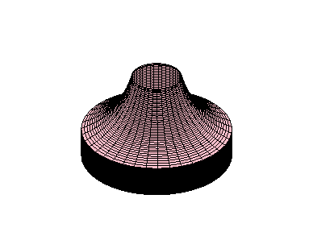
View of the solid looking upwards from the x-axis:
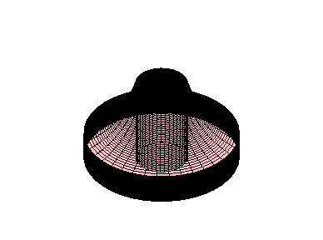
Example 2 $y = \sqrt{ x} , y = 0 , x = 9$ ; revolve about the y-axis

See Example 3 of Lesson 3 using washers. The solid of revolution is the same.

Example 3 $x^{2} = 4y , y = 2$; revolve about the x-axis
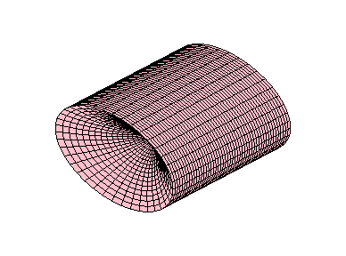

View of the solid cut in half looking from the origin down the positive x-axis:
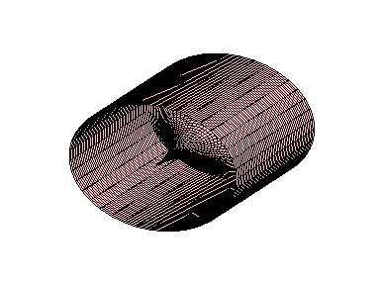
Example 4 $y = x^{2} − 5x , y = 0$ ; revolve about the y-axis
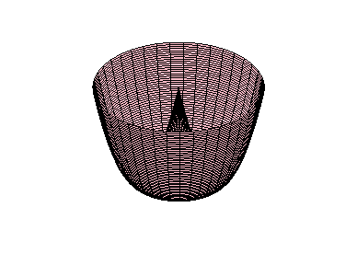
View of the solid from the bottom looking upwards to the x-axis:
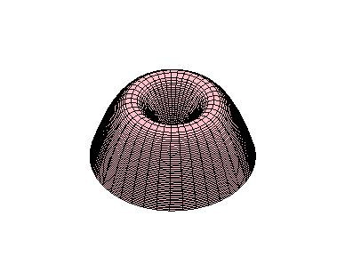
Example 5 $x = y^{2} , x = 4y$ ; revolve about the x-axis

View of the solid looking down the positive x-axis towards the origin:
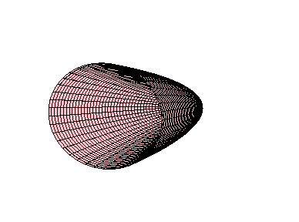
View of the solid cut in half looking down the positive x-axis towards the origin:
