Lesson 3 Volumes using Disks

Here are the solids of revolution for the examples which were worked in class using disks.

Example 1 $y = \frac{3}{x} , x = 2 , x = 6 , y = 0$ ; revolve about the x-axis
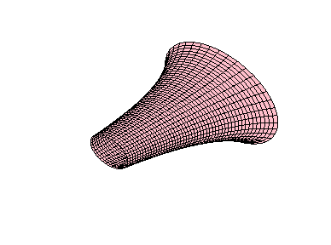
Example 2 $y = \sqrt{− x} , y = 0 , x = − 3$ ; revolve about the x-axis
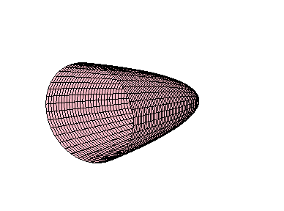
Example 3 $y = x^{2} , y = 4 , x = 0$ ; revolve about the y-axis
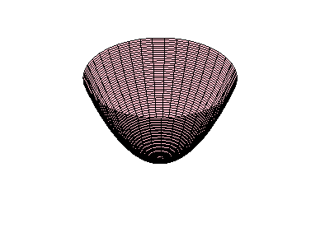
Example 4 $y = \frac{1}{x} , y = 1 , y = 4 , x = 0$ ; revolve about the y-axis
Example 5 $y = x^{2} − 6x , y = 0$ ; revolve about the x-axis
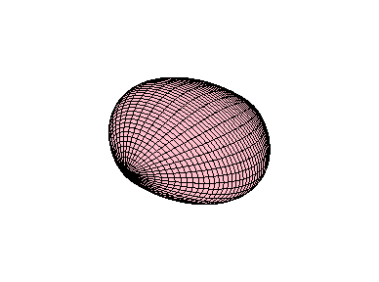
Below is the solid cut in half in order to see inside it:
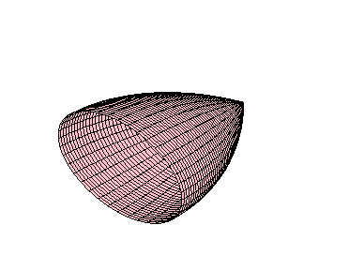
Here are the solids of revolution for the examples which were worked in class using washers.

Example 1 $y = 2x^{2} , y = 9 − x^{2}$ ; revolve about the x-axis
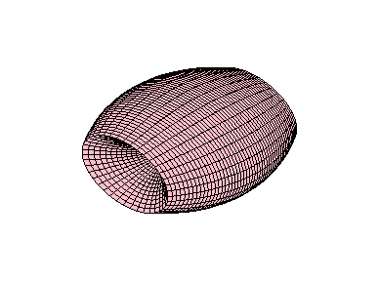
Below is the solid cut in half in order to see inside it:
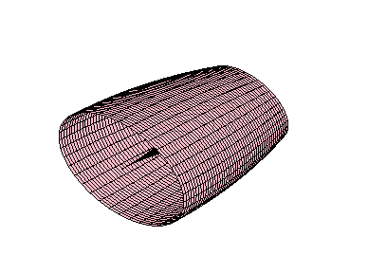
Example 2 $x = − y^{2} , y − x − 2 = 0$ ; revolve about the y-axis
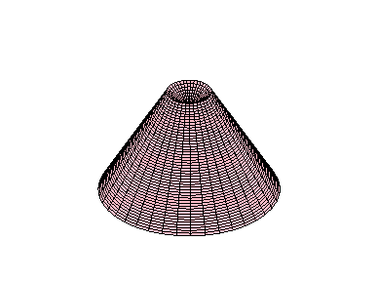
Below is the top of the solid cut through the x-axis in order to see inside it. The view is looking upward from the x-axis:
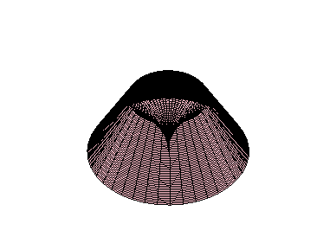
Below is the bottom of the solid cut through the x-axis in order to see inside it. The view is looking downward from the x-axis:
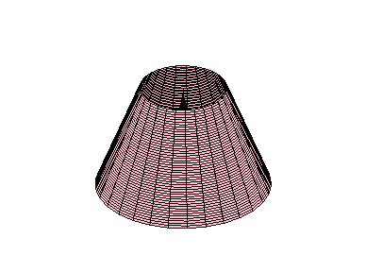
Example 3 $y = \sqrt{x} , y = 0 , x = 9$ ; about the y-axis

The view of the solid from the top:
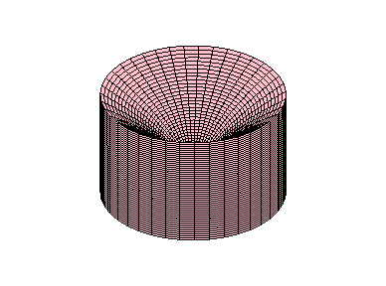

The view of the solid from the bottom:
