VOLUME OF A SPHERE

By the Disk Method: See page 380 of the textbook.

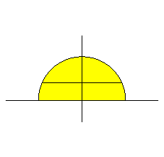
By the Shell Method: (revolving about the x-axis)

y $y = \sqrt{r^{2} − x^{2}}$ , r is a constant and r > 0
r ⁄

$(− \sqrt{r^{2} − y^{2}} , y)$ y $(\sqrt{r^{2} − y^{2}} , y)$

- r r x

Width (Thickness) = dy Height = $2 \sqrt{r^{2} − y^{2}}$ Avg Radius = y

Note: $y = \sqrt{r^{2} − x^{2}} ⇒ y^{2} = r^{2} − x^{2} ⇒ x^{2} = r^{2} − y^{2} ⇒ x = ± \sqrt{r^{2} − y^{2}}$

Volume = $\int{2π y (2 \sqrt{r^{2} − y^{2}} ) \text{dy}}$ = $4π \int{ y \sqrt{r^{2} − y^{2}} \text{dy}}$ Let $u = r^{2} − y^{2}$ Then $\text{du} = − 2\text{ydy}$

$4π \int{ y \sqrt{r^{2} − y^{2}} \text{dy}}$ = $\frac{4π}{− 2} \int{ (− 2y) \sqrt{r^{2} − y^{2}} \text{dy}}$ = $− 2π \int{ \sqrt{u} \text{du}}$ = $2π \int{ u^{1/2} \text{du}}$ =

$$2π ⋅ \frac{2}{3} u^{3/2}|_{ 0}^{ r^{2}} = \frac{4π}{3} u^{3/2}|_{ 0}^{ r^{2}} = \frac{4π}{3} [ r^{3} − 0] = \frac{4π}{3} r^{3}$$

VOLUME OF A CONE
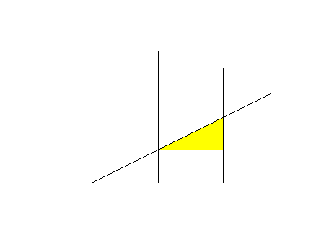
By the Disk Method: (revolving about the x-axis)

y $y = \frac{r}{h} x$ r and h are constants
$x = h$ → ↓

$( h , r)$
$( x , \frac{r}{h} x)$

x h x

Width = dx Radius = $\frac{r}{h} x$
Volume = $\int{π {\left(\frac{r}{h} x\right)}^{ 2} \text{dx}}$ = $π \int{ \frac{r^{2}}{h^{2}} x^{2} \text{dx}}$ = $\frac{π r^{2}}{h^{2}} \int{ x^{2} \text{dx}}$ = $\frac{π r^{2}}{h^{2}} ⋅ \frac{x^{3}}{3}|_{ 0}^{ h}$

= $\frac{π r^{2}}{3h^{2}} [ h^{3} − 0 ] = \frac{π}{3} r^{2}h$

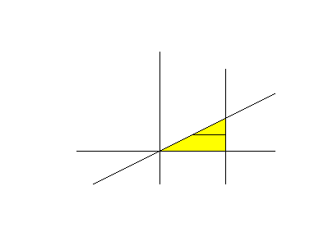
By the Shell Method: (revolving about the x-axis)

y $y = \frac{r}{h} x ⇒ x = \frac{h}{r} y$ r and h are constants
$x = h$ → ↓

$( h , r)$
$( \frac{h}{r} y , y)$ $( h , y)$

h x

Width (Thickness) = dy Height = $h − \frac{h}{r} y$ Avg Radius = y

Volume = $\int{2π y \left(h − \frac{h}{r} y\right) \text{dy}}$ = $2π \int{ \left(\text{hy} − \frac{h}{r} y^{2}\right) \text{dy}}$ = $2π {\left[\frac{{\text{hy}}^{2}}{2} − \frac{h}{r} ⋅ \frac{y^{3}}{3}\right]}_{ 0}^{ r}$

= $2π \left[\frac{h r^{2}}{2} − \frac{h}{r} ⋅ \frac{r^{3}}{3} − ( 0 − 0)\right]$ = $2π \left[\frac{h r^{2}}{2} − \frac{h r^{2}}{3}\right]$ = $2π \left[\frac{3h r^{2}}{6} − \frac{2h r^{2}}{6}\right]$

= $2π \left[\frac{h r^{2}}{6}\right]$ = $\frac{π}{3} r^{2}h$

