MATH-1860 Name _______SOLUTIONS__________
Exam 1
Spring 2003 S.I.D.# ___________________________

INSTRUCTIONS: You must show enough work to justify your answer on ALL problems. Correct answers with no work (or inconsistent work) shown will not receive any credit. The point value for each problem is given. Give exact answers. (No decimal approximations.) You are permitted to use a non-graphing calculator.

1. Sketch the region bounded by the graphs of the equations $y = − 3x^{2}$ and $y = x^{2} − 8$. Then find the area of the region. Put a box around your answer. (12 pts.)
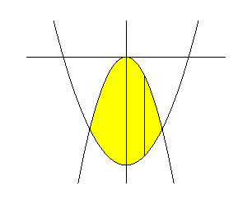
y Points of Intersection: $− 3x^{2} = x^{2} − 8 ⇒ 4x^{2} = 8 ⇒ x^{2} = 2 ⇒ x = ± \sqrt{2}$

$( x , − 3x^{2})$ x

←⎯⎯ Length = $− 3x^{2} − (x^{2} − 8) = 8 − 4x^{2}$

$( x , x^{2} − 8)$ Note: $y = 8 − 4x^{2}$ is an even function

width = dx Area = $\int{ (8 − 4x^{2}) \text{dx}}$ = $2 \int{(8 − 4x^{2}) \text{dx} =}$

$8 \int{(2 − x^{2}) \text{dx} =}$$8 {\left[ 2x − \frac{x^{3}}{3}\right]}_{ 0}^{\sqrt{2}} = 8 \left[ 2 \sqrt{2} − \frac{2 \sqrt{2}}{3} − (0 − 0)\right] = 8 \left[\frac{4 \sqrt{2}}{3}\right] = \frac{\text{32} \sqrt{2}}{3}$

Answer: $\frac{\text{32} \sqrt{2}}{3}$

2. Sketch the region bounded by the graph of the equations $x = y^{2}$ and $y = x − 2$. Then set up the integral that will give the area of the region. Put a box around your answer. (8 pts.)

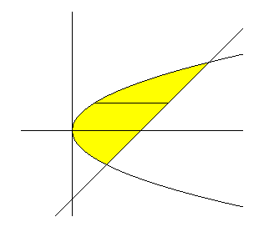
y Length = $y + 2 − y^{2} = 2 + y − y^{2}$ $y = x − 2 ⇒ x = y + 2$
⏐
⏐
⏐
$( y^{2}, y )$ ↓ $( y + 2 , y )$ Points of Intersection: $y^{2} = y + 2 ⇒ y^{2} − y − 2 = 0 ⇒$

x $(y + 1)(y − 2) = 0 ⇒ y = − 1 , 2$

width = dy Area =$\int{(2 + y − y^{2}) \text{dy}}$

3. Sketch the region bounded by the graphs of the equations $y = \frac{4}{x^{2}}$, $x = − 5$ , $x = − 3$ , and y = 0. Then set up the integral that will give the volume of the solid generated by revolving the region about the y-axis using the Shell Method. Put a box around your answer. (8 pts.)
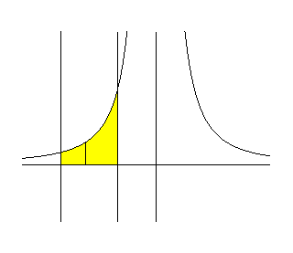
y

$\left( x , \frac{4}{x^{2}}\right)$
←⎯⎯⎯⎯⎯⎯⎯⎯⎯⎯⎯⎯ height = $\frac{4}{x^{2}}$ avg radius = $− x$
- 5 x - 3 x

thickness = dx Volume = $\int{ 2π (− x) \left(\frac{4}{x^{2}}\right) \text{dx}}$ = $− 8 π \int{ \frac{\text{dx}}{x}}$

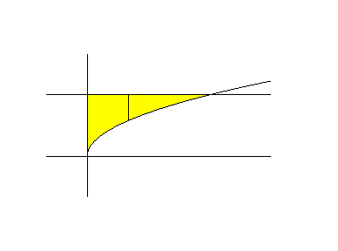
4. Sketch the region bounded by the graphs of the equations $y = \sqrt{x}$ , y = 3 , and x = 0 . Then find the volume of the solid generated by revolving the region about the x-axis using the Disk Method. Put a box around your answer. (10 pts.)

y

$( x , 3 )$ $( 9 , 3 )$ outer radius = 3
3
$( x , \sqrt{x} )$ inner radius = $\sqrt{x}$

x x

width = dx

Volume = $\int{ π (9 − x) \text{dx}}$ = $π {\left[ 9x − \frac{x^{2}}{2}\right]}_{ 0}^{ 9} = π \left[ \text{81} − \frac{\text{81}}{2} − (0 − 0)\right] = \text{81} π \left[1 − \frac{1}{2}\right] = \frac{\text{81} π}{2}$

Answer: $\frac{\text{81} π}{2}$

5. Sketch the region bounded by the graphs of the equations $x = 3 + y^{2}$, $y = 1$ , $y = 2$ , and x = 0 . Then set up the integral that will give the volume of the solid generated by revolving the region about the x-axis using either the Disk or Shell Method. Put a box around your answer. (8 pts.)

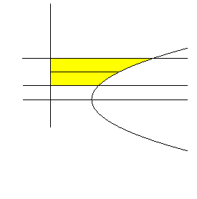
y height = $3 + y^{2}$ avg radius = y
⏐
⏐
2 ⏐
y ↓ ← $( 3 + y^{2} , y )$
1
3 x Volume = $\int{ 2π y ( 3 + y^{2}) \text{dy}}$

width = dy

6. Differentiate the following functions. Put a box around your answer.

a. $g(x) = \frac{e^{− x^{2}} + \text{tan}4x}{8 − 2x^{3}}$ (Do not simplify your answer.) (10 pts.)

$g^{'}(x) = \frac{( e^{− x^{2}}(− 2x) + 4{\text{sec}}^{2}4x)(8 − 2x^{3}) − ( e^{− x^{2}} + \text{tan}4x)(− 6x^{2})}{(8 − 2x^{3})^{2}}$

b. $y = (3^{− t} + 5^{t})^{6}$ (Do not simplify your answer.) (6 pts.)

$\frac{\text{dy}}{\text{dt}} = 6 (3^{− t} + 5^{t})^{5} [ 3^{− t}(\text{ln}3)(−1) + 5^{t}\text{ln}5 ]$

c. $e^{ 2x} − y^{4} = x\text{cos}y$ (10 pts.)

$2e^{ 2x} − 4y^{3}y^{'} = \text{cos}y + x ( − \text{sin}y) y^{'}$ ⇒ $2e^{ 2x} − 4y^{3}y^{'} = \text{cos}y − x y^{'} \text{sin}y$ ⇒

$2e^{ 2x} − \text{cos}y = 4y^{3}y^{'} − x y^{'} \text{sin}y$ ⇒ $2e^{ 2x} − \text{cos}y = y^{'}( 4y^{3} − x \text{sin}y )$ ⇒

$y^{'} = \frac{2e^{ 2x} − \text{cos}y}{4y^{3} − x \text{sin}y}$

7. Evaluate the following integrals. Put a box around your answer.

a. $\int{ \frac{\text{dx}}{e^{3x}}}$ (8 pts.) Let $u = −3 x$
$\text{du} = − 3 \text{dx}$

= $\int{ e^{− 3x} \text{dx}}$ = $− \frac{1}{3} \int{ e^{− 3x} (− 3)\text{dx}}$ = $− \frac{1}{3} \int{ e^{u} \text{du}}$ = $\frac{1}{3} \int{ e^{u} \text{du}}$ =

$\frac{1}{3} {\left[ e^{u}\right]}_{ 3}^{ \text{12}}$= $\frac{1}{3} (e^{\text{12}} − e^{3})$

b. $\int{\frac{6^{\sqrt{t}}}{5 \sqrt{t}} \text{dt}}$ (8 pts.) Let $u = \sqrt{ t}$
$\text{du} = \frac{1}{2 \sqrt{ t}} \text{dt}$

= $\frac{1}{5} \int{\frac{6^{\sqrt{t}}}{\sqrt{t}} \text{dt}}$ = $2 ⋅ \frac{1}{5} \int{\frac{6^{\sqrt{t}}}{2\sqrt{t}} \text{dt}}$ = $\frac{2}{5} \int{ 6^{u} \text{du}}$ = $\frac{2}{5} ⋅ \frac{1}{\text{ln}6} 6^{u} + c$ = $\frac{2}{5} ⋅ \frac{6^{\sqrt{ t}}}{\text{ln}6} + c$

8. Given the function $f(x) = x^{3}e^{4x}$, find the following: (17 pts.)

a. Interval(s) on which f is increasing: $\left(− \frac{3}{4} , ∞\right)$

b. Interval(s) on which f is decreasing: $\left(− ∞ , − \frac{3}{4}\right)$

c. Local maximum(s) of f ____None________

d. Local minimum(s) of f : $− \frac{\text{27}}{\text{64}} e^{− 3}$ OR $− \frac{\text{27}}{\text{64} e^{3}}$

$f^{'}(x) = 3x^{2}e^{4x} + x^{3}e^{4x}4 = x^{2}e^{4x}(3 + 4x)$

$f^{'}(x) = 0 ⇒ x = 0 , x = − \frac{3}{4}$ $f^{'}(x)$ undefined: Nowhere

− + + Sign of$f^{'}(x)$
⎢ ⎢
$− \frac{3}{4}$ 0 $f \left(− \frac{3}{4}\right) = − \frac{\text{27}}{\text{64}} e^{− 3} = − \frac{\text{27}}{\text{64}e^{3}}$
9. A heavy cable, 70 feet long, weighs 2 pounds per foot and hangs over the edge of a building 100 feet tall.
Set up the integral that will give the work done in pulling the cable to the top of the building. (10 pts.)
Put a box around your answer.

$\text{100} \begin{aligned} \\ \end{aligned}$ $\text{100} − y$
←⎯⎯ Weight (Force) = $2 (\text{100} − y)$

Work = $\int{ 2 (\text{100} − y) \text{dy}}$

